**Dataset: Sample superstore.xlsx**

**Sheet 1: Display Region wise Sales.**

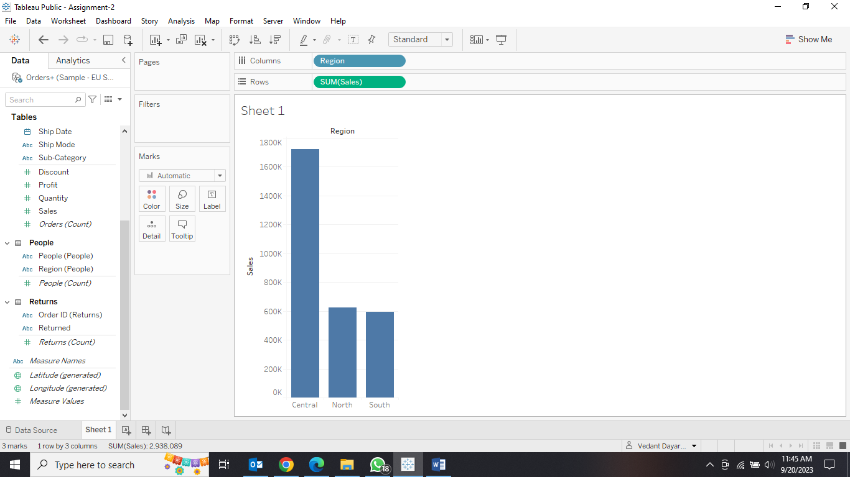

**Sheet 2: Display Segment wise Profit for Furniture and Technology Category only.**

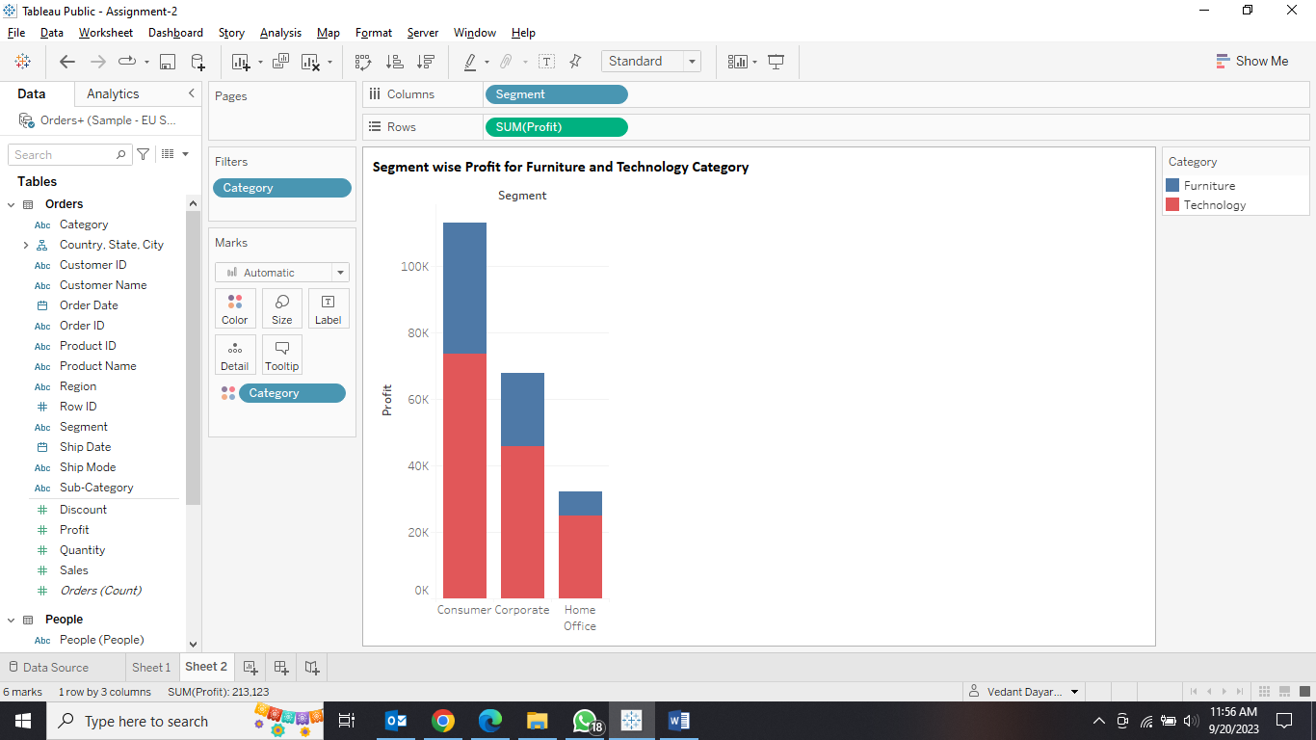

**Sheet 3: Display Profit as a tooltip value for sheet 2.**

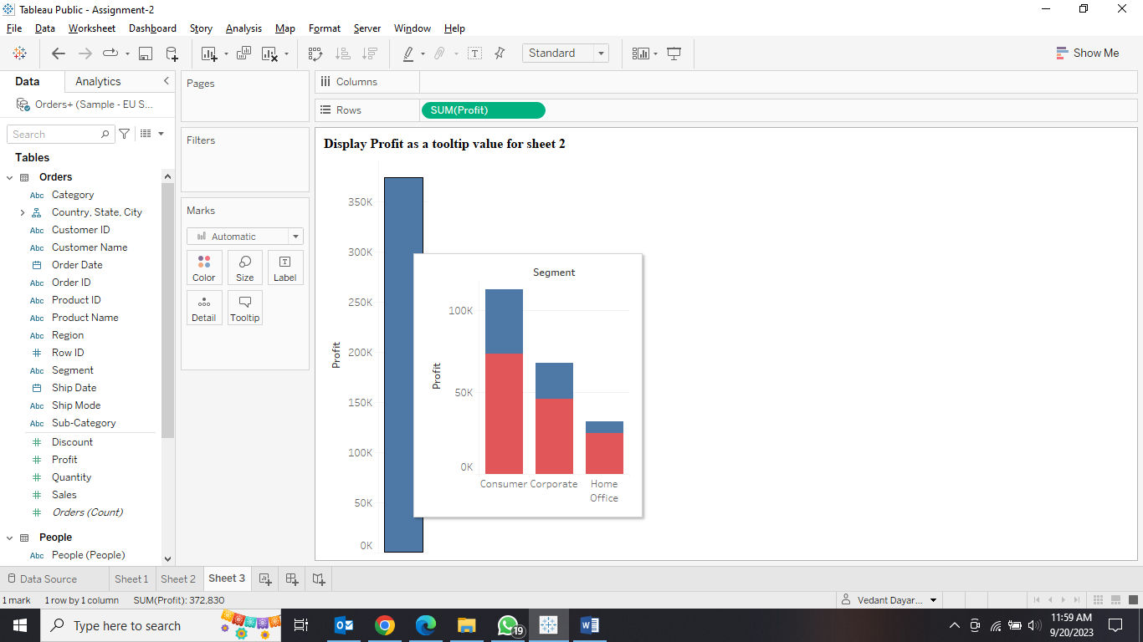

**Sheet 4: Display Total Quantity Wise Ship Mode use blue colour theme.**

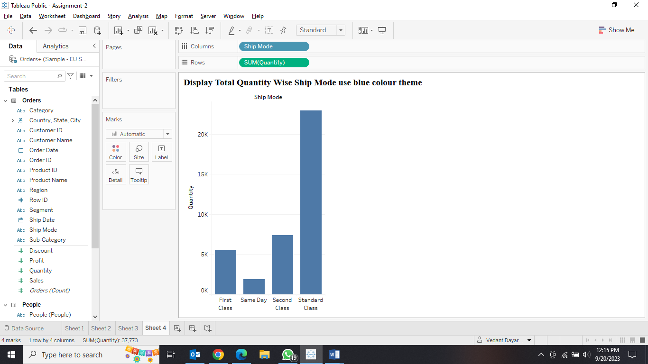

**Sheet 5: Display Day by day sale from January to December for given order date.**

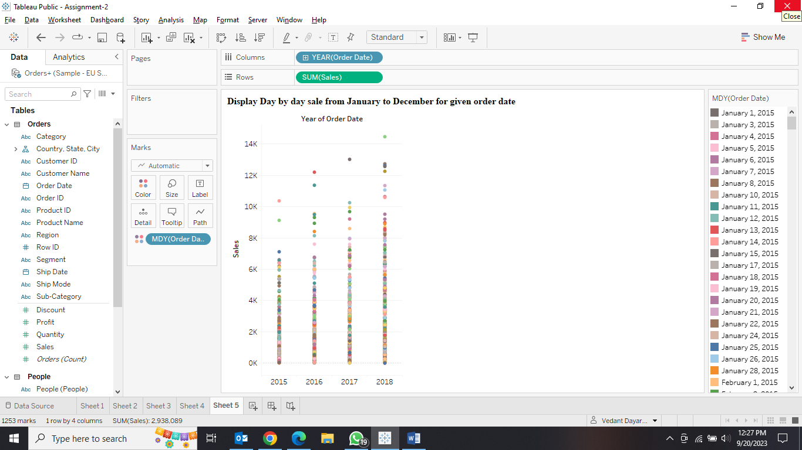

**Sheet 6: Display Country wise sale for UK, Italy and Finland country having sale range between greater than 70K and less than 4 Lac.**

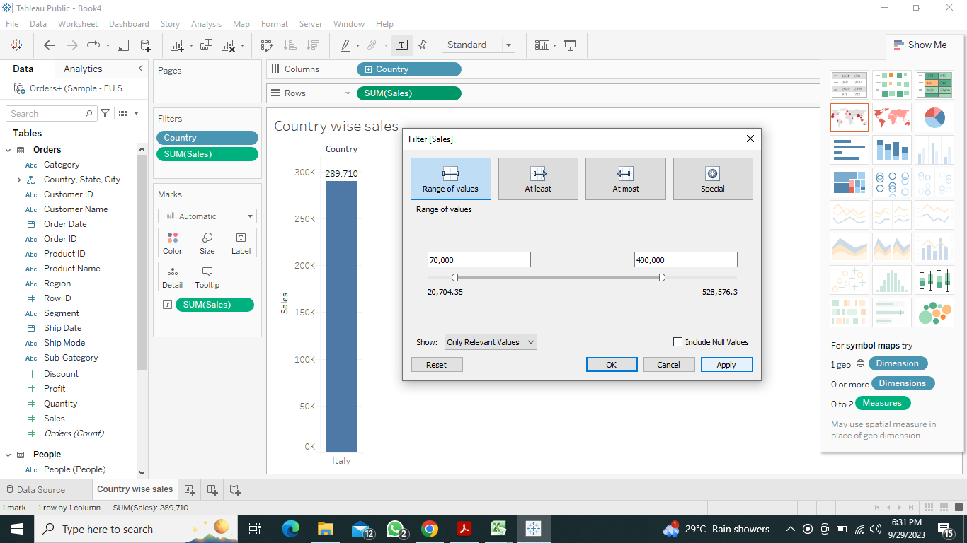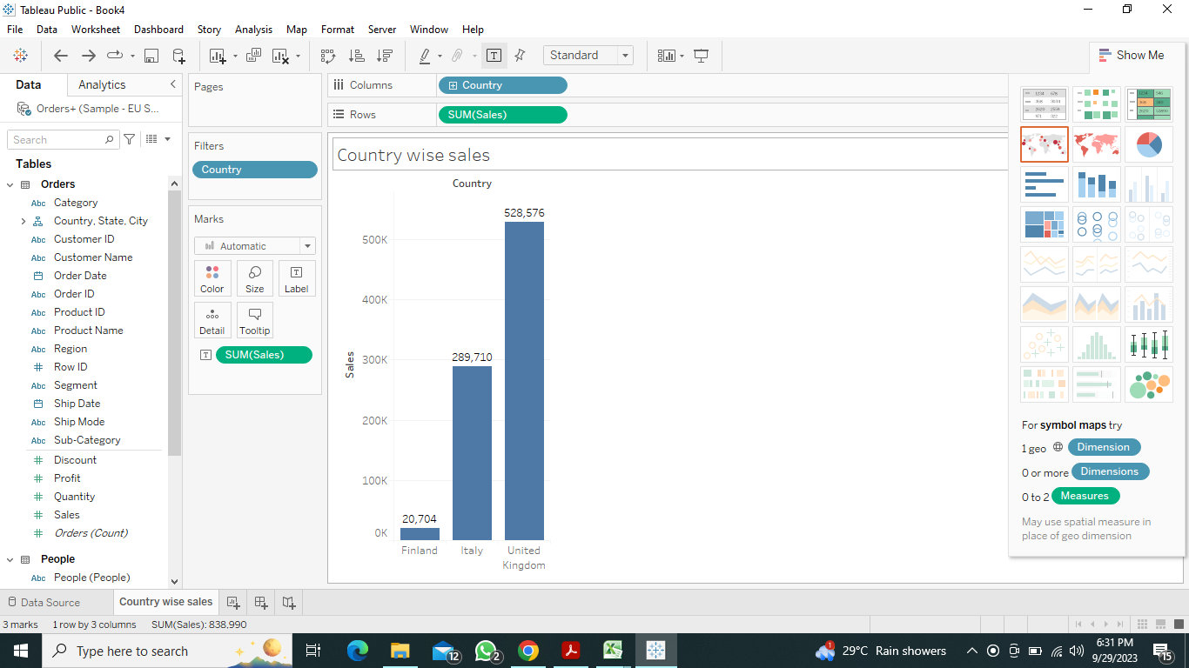

**Sheet 7: Apply nested and non-nested sort for Category, Sub-Category and their respective sale value.**

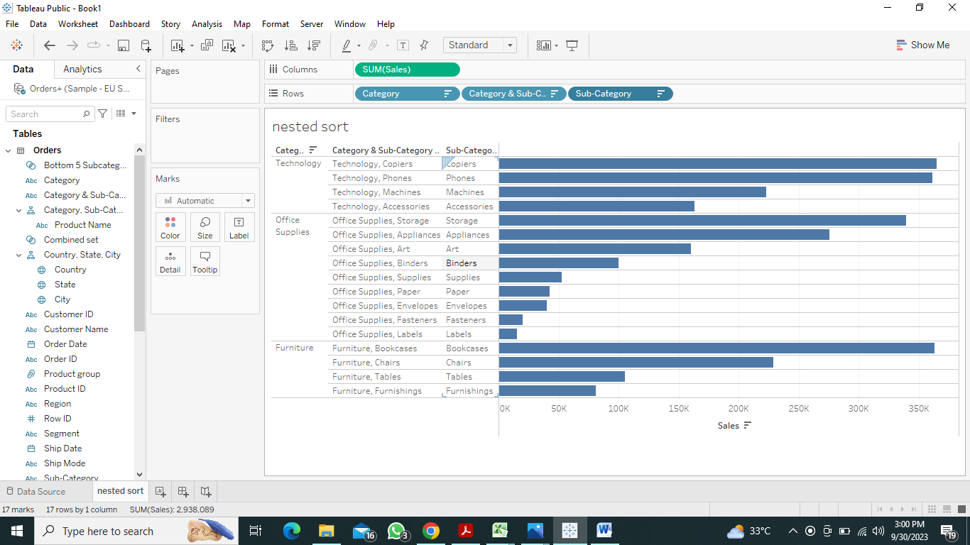

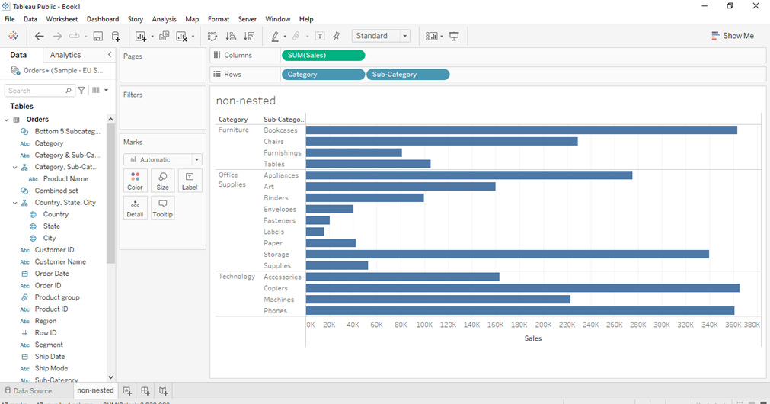

**Sheet 8: Create Product group for Refrigerator, Phone and Clock and display their respective sale value.**

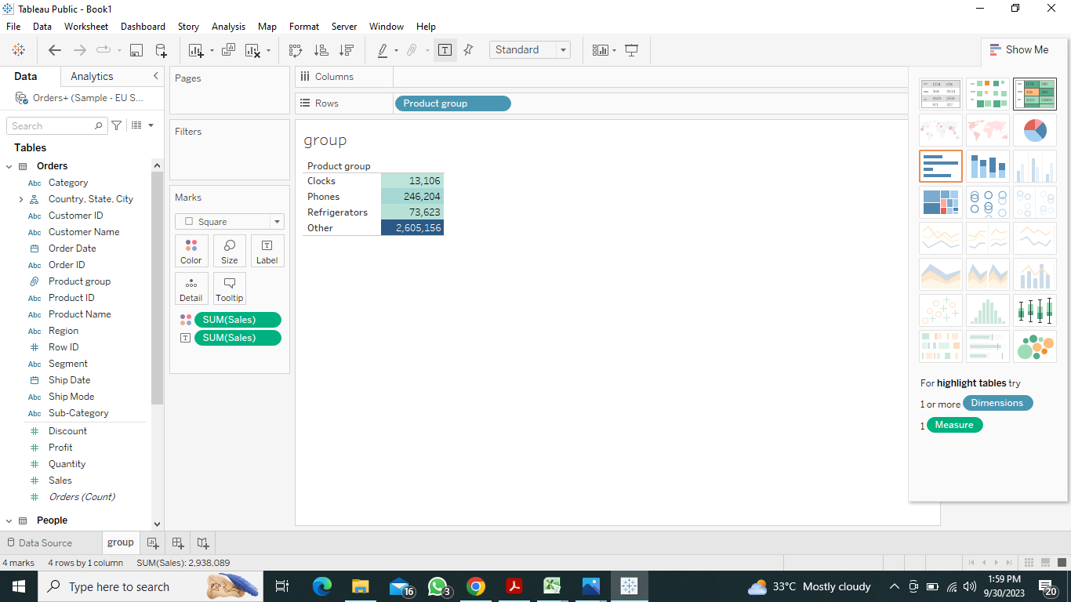

**Sheet 9: Create Product hierarchy having Category->Sub-category->Product Name.**

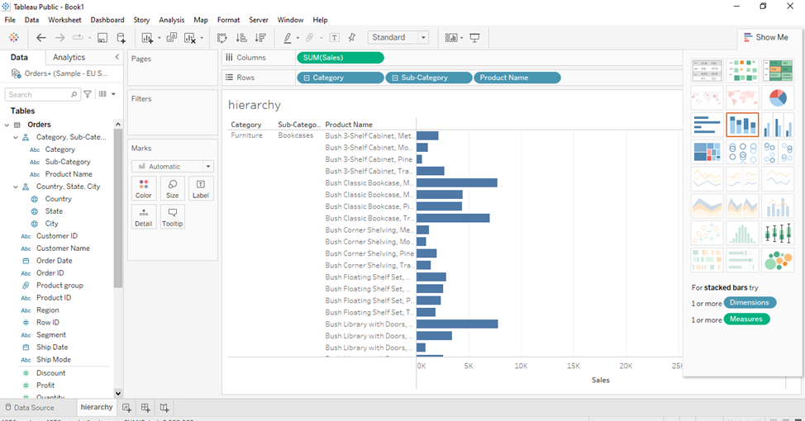

**Sheet 10: Create Location hierarchy having Country->State->City->Postal Code.**

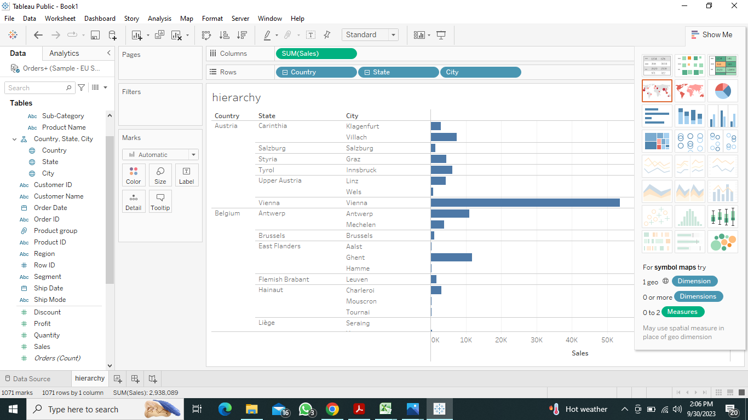

**Sheet 11: Create Combine Set having common member between two sets Subcategory having bottom 5 members by sale and Subcategory having Sum (Sale)>=50K.**

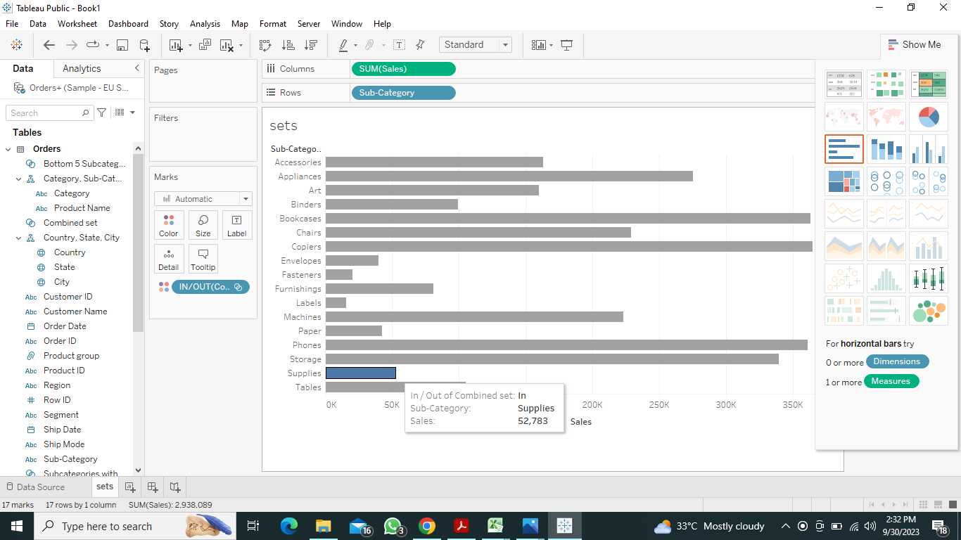

**Sheet 12: Display Top N and Bottom N subcategory by sale enter by user in parameter window.**

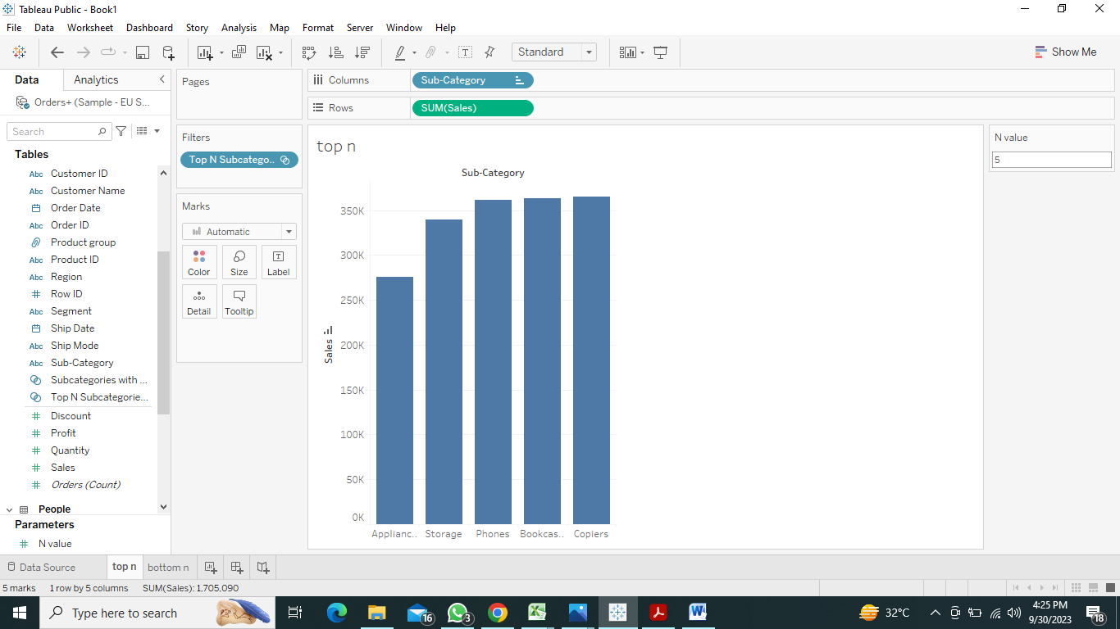

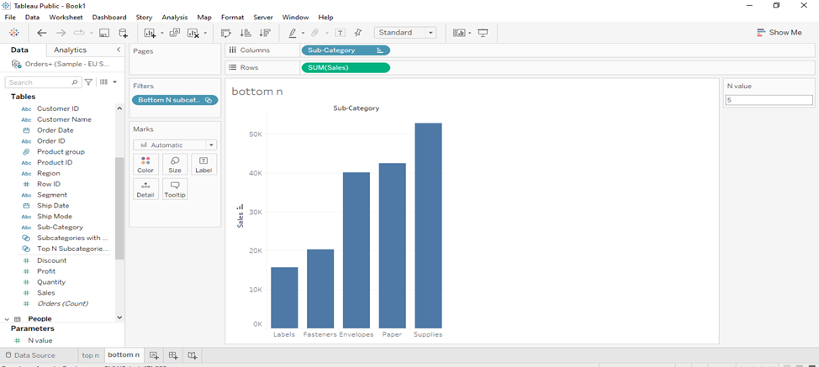

**Sheet 13: Show date range to_date and from_date entered by user and display month wise sale for order date.**

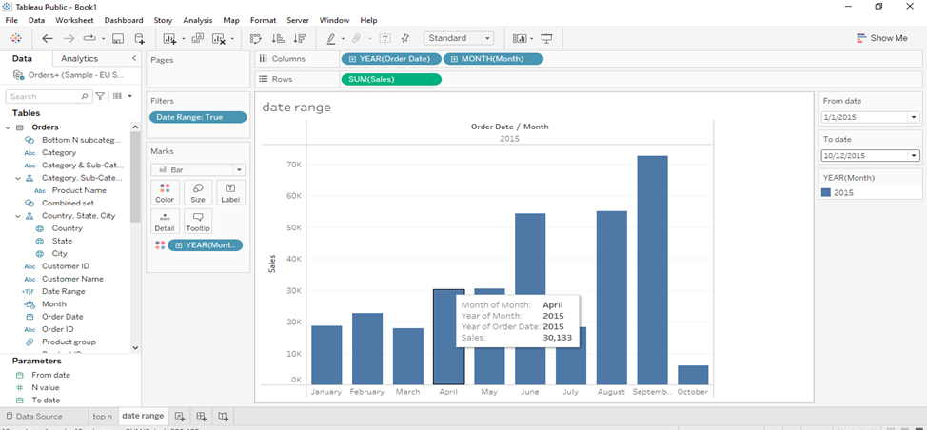

**Sheet 14: Show dynamic graph trend for year, quarter, month, week, day as per user selection.**

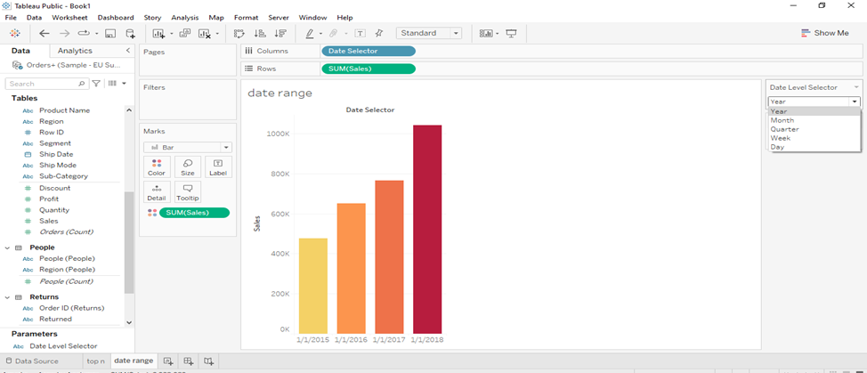

**Sheet 15: Using dual axis display Average sales and percentage of running total of sales for month of order date.**

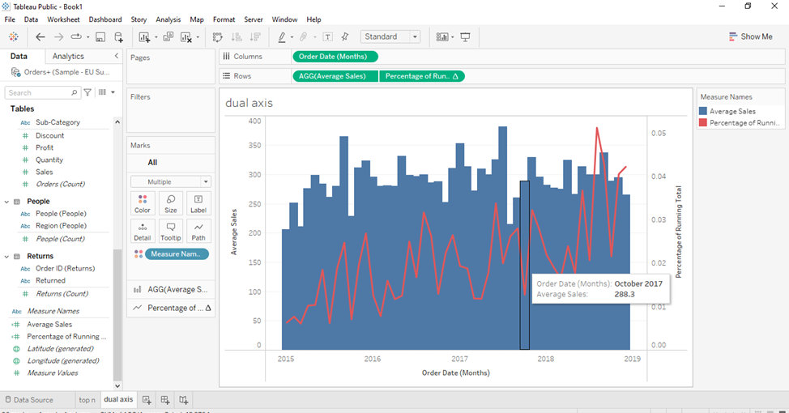

**Sheet 16: Display reference band for median value Segment wise Sum(sales).**

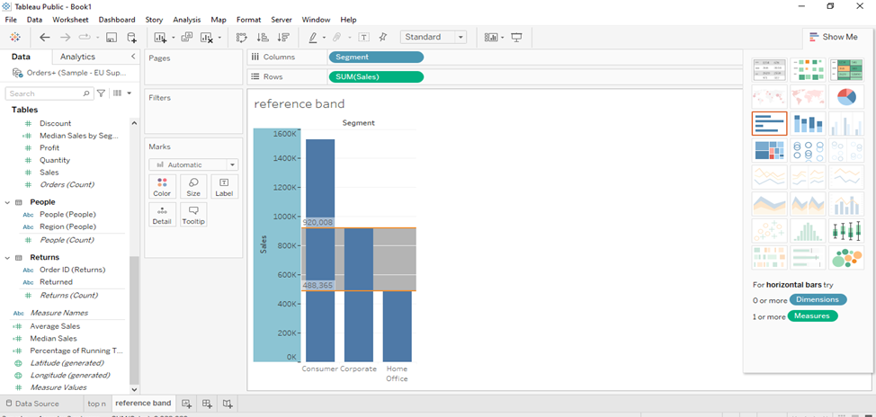

**Sheet 17: Display reference band of user selected range for month of order date and Average of profit values.**

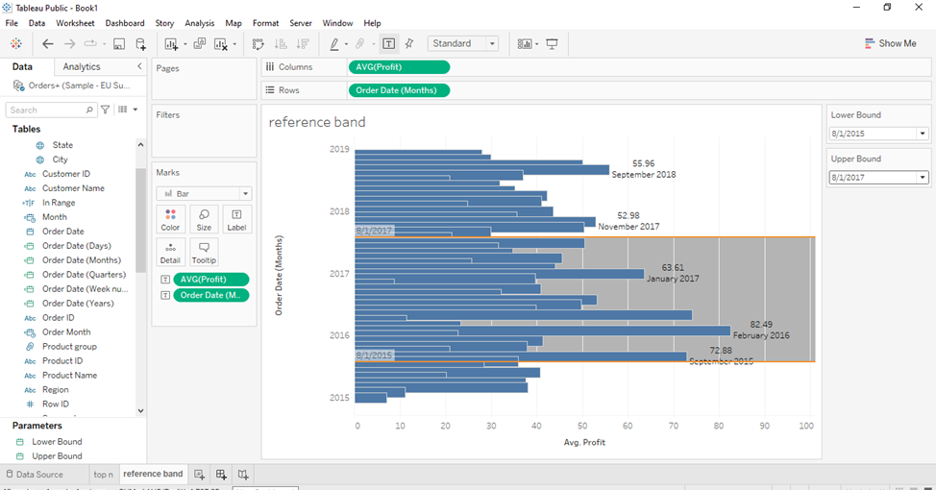

**Sheet 18: Show reference distribution for Sum (Sales) and Category for minimum value to maximum value of axis.**

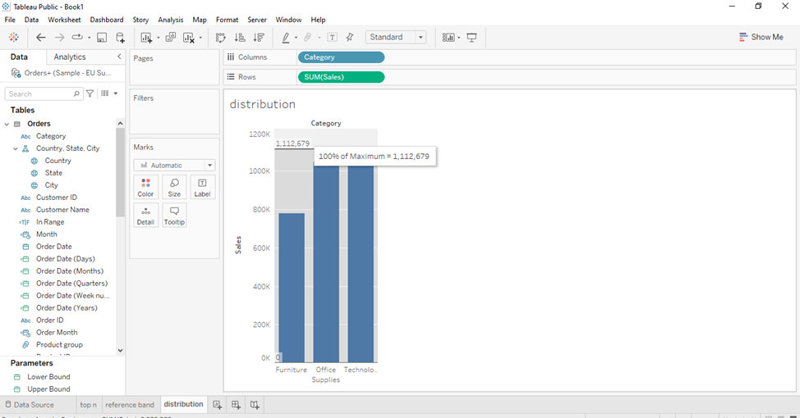

**Sheet 19: Show scatter plot for sales and profit. Also display a statistical summary card for a given chart.**

